

Virtual International Hackathon

**Institutions:**

* **Concordia University Chicago (CUC)**
* **Universidad Católica de Santa Fe (UCSF)**

**Team 8:**

Kate Johnson – CUC, USA.

Robert Sorensen – CUC, USA

Sebastián Wasinger – UCSF, Argentina.

Agustín Philippeaux – UCSF, Argentina.

# Summary

## Executive Summary

* 1. Product/Service
  2. Customers
  3. Future of the company and why the digital implementation is needed
  4. Company description: mission, management team, legal structure

## Company’s Environmental Summary

* 1. **External Analysis:**
     1. Description of the industry’s digital initiatives. ii.PESTEL Analysis.

iii.Competitive forces: Five-Forces Model. iv.Key findings from the external analysis.

## Internal Analysis:

1. Key resources of the firm.
2. SWOT analysis.
3. Key findings from the internal analysis.

## Evaluate and Propose a Solution/Change

1. **Recommendations and Their Impact**
   1. Closing Statement

# Executive summary

## Introduction to the company

Within the framework of work between CUC & UCSF students, we're working on a case study for <<Elevadores Neumáticos SA>> , a residential elevator company founded in 1994 and based in Paraná, Entre Ríos.

## Product/Service

ENSA's flagship product is its VACUUM elevator, which uses a unique technology that allows it to operate without a machine room or a pit. ENSA sells three main models, a one, two, and three person option that all can be installed and serviced in one to two days. The PVE52 (1316) model is recommended for those in wheelchairs which can be installed between two, three, and four floors high.

## Customers

A residential elevator company's customers can include a wide range of individuals and groups involved in the design, construction, and maintenance of residential elevators. Homeowners are customers for this residential elevator, people who want to put elevators in their homes for convenience, accessibility, or luxury.

## Future of the company and need for digital implementation

The company is using technology to improve its products and services, and to meet the changing needs of its customers. Cube Lifts use technology to remotely monitor and maintain its elevators, which reduces downtime and improves the customer experience. They use technology to make their elevators more energy-efficient and to protect the security of their infrastructure and customer data. The use of digital innovation and technology is essential to the future of Cube Lifts Home Elevators

## Company description:

* **Mission:** Provide customers in the US and European markets with residential elevators, reliable and customized service, and an enjoyable online experience. Improving home accessibility, particularly for those with mobility issues, the company prioritizes developing products in order to provide safe, dependable, and advanced residential elevator solutions.
* **Vision:** Diversify customer base and create new franchises in Latin America, serving in growing markets with improved operations and efficiency by reducing the use of paper.
* **Values:** Customer satisfaction, eco-friendly with the environment, efficiency, team work, high- quality elevators, commitment, sustainability, continuous learning.
* **Company’s culture:** They’re planning a HR area to identify talents,reinforce loyalty between employees and increase job satisfaction, leading to a higher retention.

# Company’s Environmental Summary

## External analysis

**Description of the industry’s digital initiatives**

ENSA, a residential elevator manufacturer, is undertaking a digital initiative to digitize its employee files. The residential elevator manufacturing industry is increasingly embracing digital initiatives to improve efficiency, reduce costs, and deliver better value to customers.

To better understand the company's position in the market, we will conduct a PESTLE analysis, which is a tool used to identify and analyze the external factors that can impact a business.

**Pestle Analysis**

|  |  |
| --- | --- |
| **Technological** | * Track and assess the technological advancements of competitors * Technology is essential in producing complex machines like elevators which must work safely |
| **Economic** | * Elevators must be properly priced in order to attract global consumers * Must ensure supply chains are stable and reliable * Inflation rates when selling products across multiple countries |
| **Social** | * Must create/improve new channels of informative content like blogs, articles and videos * Keep consumers interested in your product through social media and email marketing * Consumer preferences and attitudes towards sustainability can also impact ENSA's business |
| **Political** | * Must consider international policy/taxation and governmental regulation * Political stability and the importance of elevators within a global economy |
| **Legal** | * Follow all antitrust laws and all copyright/patent laws * Issue consumer protection (if customers don't receive a product or product doesn’t work properly) |
| **Environmental** | * Use eco-friendly materials in the elevator manufacturing process * Reduce greenhouse gas emissions from the process |

## Competitive forces

Is a strategic business tool that can be used to analyze the competitive landscape of an industry and identify opportunities and threats. It is based on the idea that five forces determine the intensity of competition and profitability of an industry.

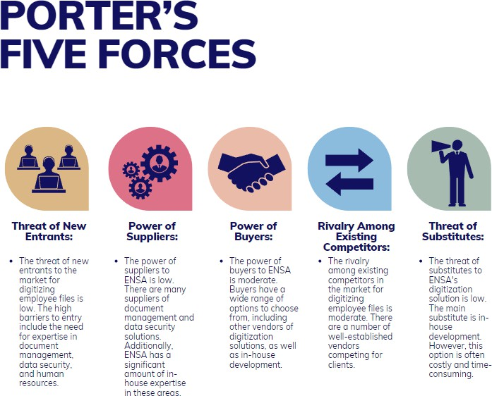

## Key findings

The company faces low threats from new entrants and substitutes, and its buyers and suppliers have moderate power. However, the company does face moderate rivalry from existing competitors. Additionally, ENSA should differentiate itself from its competitors by offering excellent customer service and support.

"The company that doesn't have a clear understanding of the five forces is at the mercy of its competitors." **(Porter, 1980)**

## Internal analysis

Based on the information provided by the company, the key resources are:

* **Human resources:** A staff of 100 employees with a variety of skills and expertise, including engineers, production workers, administrative staff, and sales and marketing professionals.
* **Physical resources:** ENSA's 5,000 m2 plant in Paraná, Argentina, houses production, administration, and management, as well as manufacturing equipment and storage facilities.
* **Intellectual resources:** Proprietary VACUUM elevator technology gives the company a competitive advantage in the market. The company also has a number of patents and trademarks associated with its technology and products.
* **Financial resources:** Is a profitable company with a strong financial position. The company has the financial resources to invest in new product development, market expansion, and operational efficiency initiatives.
* **Brand reputation:** Strong brand reputation for quality, innovation, and customer service. This gives the company a competitive advantage in the market and helps it attract and retain customers.
* **Supplier relationships:** Strong relationships with its suppliers. This ensures that the company has access to high-quality materials and components at competitive prices.

## SWOT Analysis

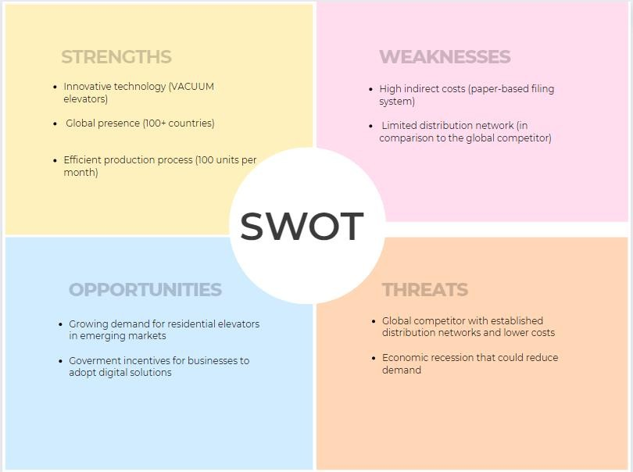

**Key findings**

Overall, ENSA has a number of strengths that it can leverage to achieve its strategic goals. However, the company also faces some weaknesses and threats that it needs to address. The internal analysis has identified several opportunities that ENSA can pursue to grow its business and maintain its competitive advantage.

Despite these challenges, ENSA has several opportunities to grow its business and maintain its competitive advantage. One opportunity is to digitize employee files. This would reduce costs, improve efficiency, and create a centralized database of employee information that could be used to improve decision-making and employee satisfaction.

# Evaluate and propose a solution

In today's digital age, it is essential that organizations and their leaders keep up with technological advances, such as transforming from an analog company to a digital one. This would allow them to grow exponentially.

Nowadays, relationships between companies are characterized by a shifting balance of competition and collaboration. We need to understand this dynamic in order to succeed in today's business landscape. **Better relationships means better results.**

Consider the idea that Digital Transformation involves new ways of thinking about customers, we believe that the organization should base its strategic plan on technology but without neglecting the well-being of people in order to achieve the goals set.

The DG process is complex and requires change in organizational culture, processes, and technology. To guide the organization in this process, it is important to consider the following aspects:

* The cost of obtaining, processing, and storing data is decreasing.
* Globalization makes competition tougher and changes customer expectations.
* Data is a strategic asset for innovation and decision-making.
* Having a work-from-home friendly may enhance the company’s horizon, by establishing a culture of trust and autonomy.

## Recommended steps to success:

* **Start with project planning,** considering the application of an MVP because the fundamental idea is to make mistakes quickly and cheaply to learn a lot.
* **Implement a SharePoint** that serves as a shared space for employees to access and collaborate.
* **Create an Excel file within SharePoint,** where a form will be created that allows staff to enter their information.
* **Create a database**, using open-source engines such as MySQL to adapt to the new ecosystem.
* **Load the Excel files into the database** to allow workers to querydata, polish it, and obtain insights. The polished data should be saved in a different file.
* **Load the file with the polished data into** a visualization software such as **Power BI** and start generating a dashboard that summarizes the most relevant aspects of the collected data to help in decision-making.
* **Evaluate the project** to measure the success of the project or correct deviations.

By following this procedure, the digitization of information is ensured, reducing furniture and paper use, as well as the ability to polish data to convert it into valuable information that facilitates decision-making.

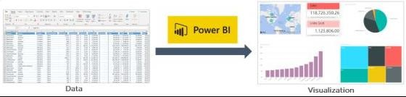

Figure 1: Simple Data Architecture Schema. Source: [Simplilearn](https://www.simplilearn.com/tutorials/power-bi-tutorial/what-is-power-bi)

## Main benefits of applying this methodology:

* + **Improved efficiency:** All of the organization's information can be managed in a much more efficient and secure way.
  + **Personalization:** The implementation of a data technology architecture will allow ENSA to personalize the customer experience, by creating segmented information. This improvement will produce greater satisfaction and loyalty.
  + **Expansion to new markets:** By maintaining a constant digital presence, whether through blogs, email marketing, or social media, ENSA can reach potential new customers.
  + **Learning and Adaptation:** Foster a culture of continuous learning and development, in which the employees can acquire new skills and advanced their professional development.



Figure 2: ENSA's Residential Elevator, model: PVE 30 . Source: [ENSA’s website](https://ensa.com.ar/nuestros-ascensores/ascensor-neumatico-pve30/)

# Recommendations and their impact

In summary, the proposed strategic plan for Elevadores Neumáticos SA (ENSA) seeks to address the issue of paper document management, with a focus on digitization and digital transformation. This change supports the achievement of strategic objectives such as reducing indirect costs, improving employee well-being, reducing paper usage, and recovering the space used for filing records.

ENSA's recommendations aim to leverage its existing strengths, such as its innovative elevator technology and global presence, to maintain its competitive position and provide more efficient services. The recommendations also directly address the identified weaknesses, such as the high indirect costs associated with paper management and the inefficient document management system.

* + - **Operational Efficiency:** The digitization of documents and the creation of a centralized database would improve the operational efficiency of ENSA. Processes related to employee records management and decision-making would become faster and more efficient.
    - **Quick Access to Information:** The centralized database and the digital document management system would allow for quick and easy access to employee information.
    - **Data Security:** Digitization would reduce the security risks associated with paper files. Digital data could be protected with more robust security measures.
    - **Data-Driven Decision-Making:** The centralized database and the ability to query and analyze data would allow for more informed and data-driven decision-making.
    - **Adaptation to the Digital Economy:** Digitization is essential to adapt to the current digital economy. Companies that operate in a digital environment are better positioned to compete and meet the changing demands of customers, such as accessing a large pool of professionals without demographic limits.
    - **Expansion and Digital Presence:** ENSA could leverage its digital presence to reach new markets and customers through blogs, email, and social media.
    - **Digital Organizational Culture:** Fostering a culture of continuous learning and development, as well as a work environment that is friendly to telecommuting, is essential in the digital age.

## Closing statement:

In summary, the proposed strategic plan for Elevadores Neumáticos SA (ENSA) seeks to digitize and centralize paper documents, avoiding the inefficiencies of paper document management. This will improve efficiency, access to information, security, and decision-making, helping adapt to the digital economy and expand its presence. The plan aligns with company’s strengths and addresses its weaknesses.

The timely implementation of these recommendations will enable ENSA to move towards more efficient and effective document management in a digital business environment, resulting in significant cost and employee satisfaction benefits.

Bibliography

* Porter, Michael E. (1980). Competitive Strategy: Techniques for Analyzing Industries and Competitors. New York: Free Press.
* Rogers, D. (2016). The digital transformation playbook: Rethink your business for the digital age. New York: Columbia Business School Publishing.
* Probert, C., & Speth, C. (2015). The SWOT analysis: A key tool for developing your business strategy (Management & Marketing). London: Pearson.
* David, F. (2011). Strategic planning and management: A PESTLE analysis. Pearson Education.